extended Abstract PREPARATION guideline
Name1 Surname1 ¹, Name2 Surname2 ²
¹Institute of Mathematics, Czestochowa University of Technology,
Czestochowa, Poland
²Institute xxxxx, University xxxxx,
Warszawa, Poland
¹name1.surname1@server1.pl, ²name2.surname2@server2.pl
Text of the extended abstract should be prepared in Word editor for Windows operating system (versions: 2000 above) in English. Capacity: 2 to 6 pages A4, no less than 1500 characters in length. Even page number of the abstract is preferred. Margins on the A4 sheet: top – 3.6 cm, bottom – 6.4 cm, left , right – 4 cm. Title of the abstract: Times New Roman 12 pt, bold italics, centred, space 12 pt above and 36 pt below the title (style: SIMI_tyt). Name and surname of the author (authors): Times New Roman 10 pt, bold italics, centred (style: SIMI_autor). Workplace (organizational unit, university, e-mail): Times New Roman 9 pt, italics, centred, space 6 pt above and 20 pt below the workplace (style: SIMI_miejsce). Text: Times New Roman 11 pt, text justified on both sides, space between verses: singular, beginning of a paragraph: indenting 5 mm (style: SIMI_tre).
Headers should include the name of the conference.
Formulas, e.g. (5), should be created with “Microsoft’s” equation editor or other compatible editor, leaving 9 pt spacing before and after it (style SIMI_wzor). Formulas and symbols: italics; matrices and vectors: bold; formula numbering on the right side.
(5)
or
(6)
Font size within formulas: Basic (Normal): 11 pt, Subscript/superscript: 7 pt, Inferior subscript/superscript: 6 pt, Symbol: 17 pt, Sub-symbol: 11 pt.
Figures and graphs may be created with a discretionary technique in order to provide a legible black and white printout.
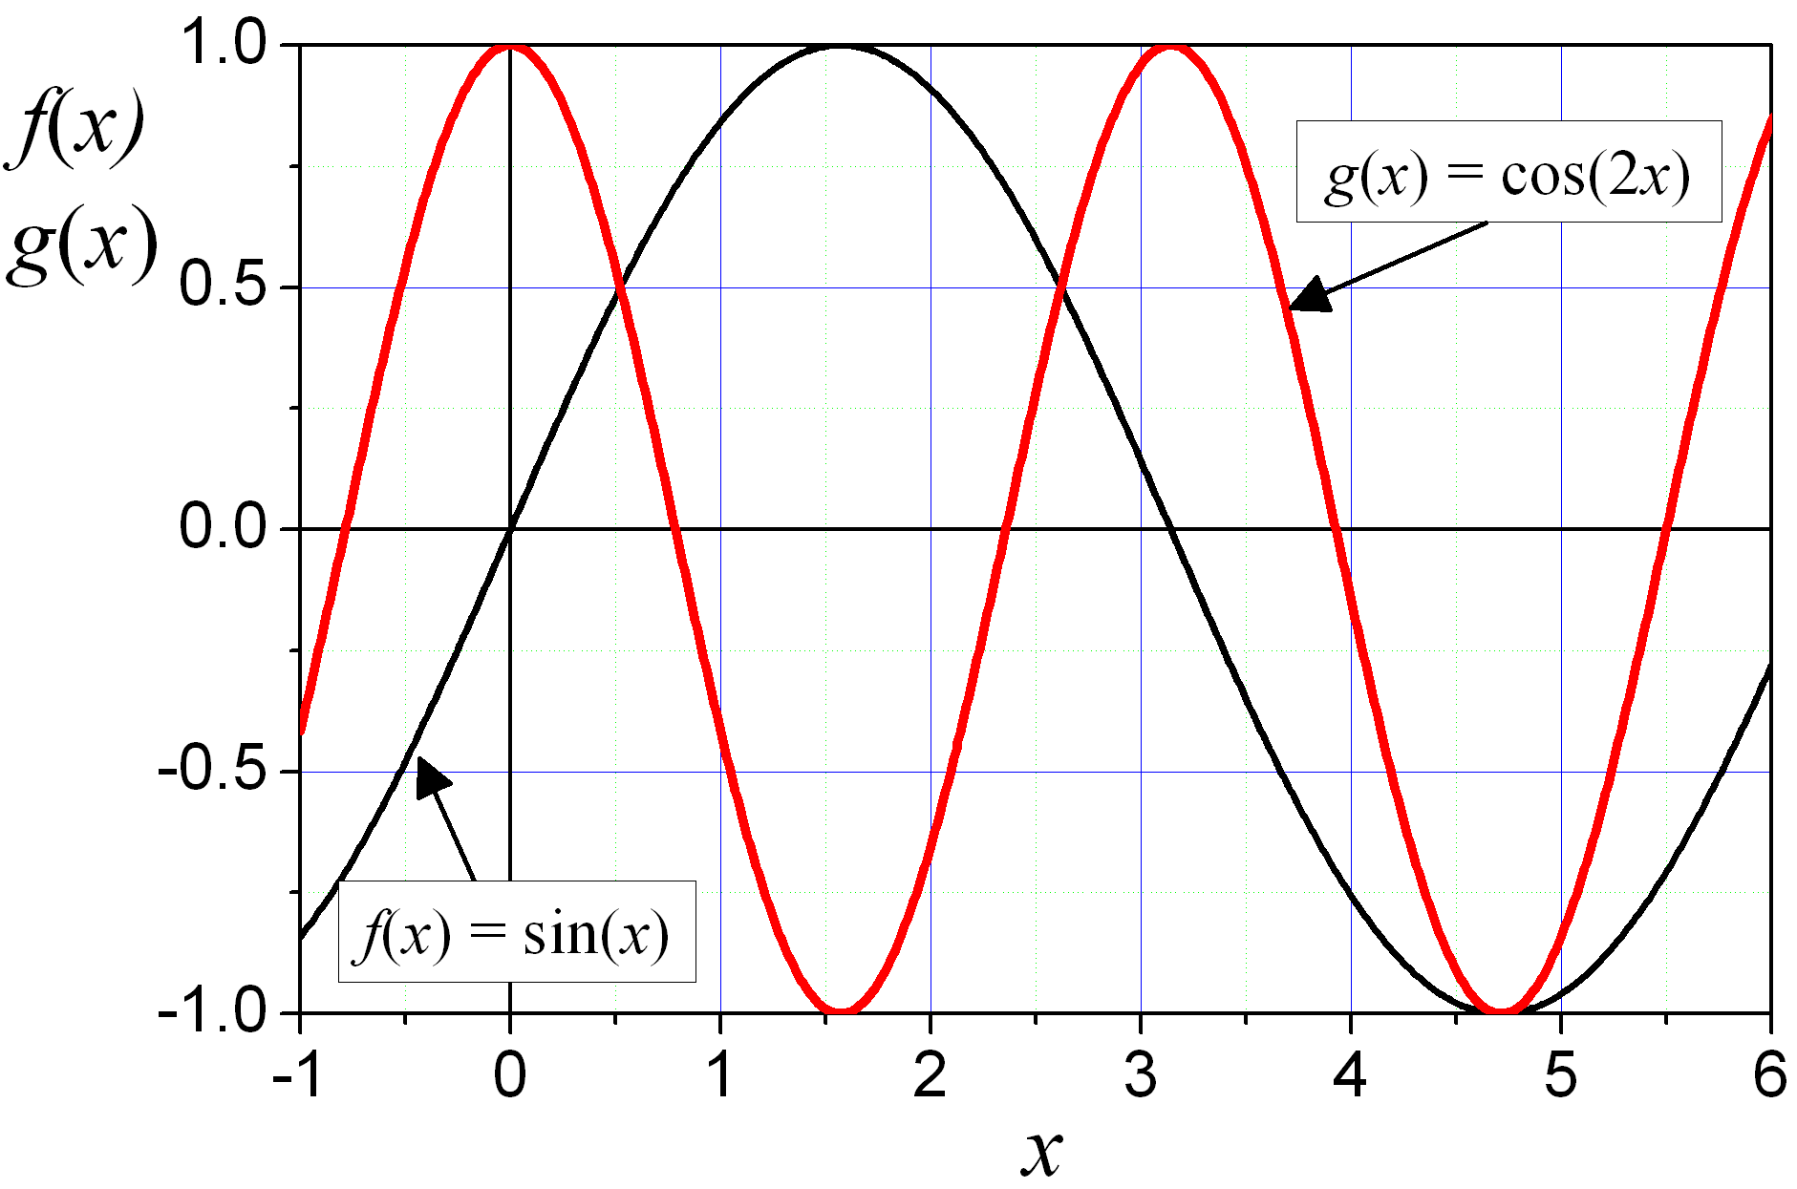
Fig. 1. Graph of a function f(x) = sin(x) oraz g(x) = cos(2 x)
Description of figures: Times New Roman 9 pt, centred, spaces 5 pt above and 14 pt below the figure’s designation (style: SIMI_rys), figures’ width cannot exceed 13 cm.
Citing the publication in the form of a book [1] or an article [2] is presented in the section after the word References. The list is to be prepared with a 9 pt font (do not use any distinctions, e.g. italics or bold), text is to be justified, numeration must be put in square brackets; references are to be presented according to the sequence of citing (non-alphabetically) (style: SIMI_literat).
Literature should be listed in accordance with the examples as below.
Keywords: mathematics, computational mechanics
References
- Podlubny I., Fractional Differential Equations, Academic Press, San Diego 1999.
- Lakshmikantham V., Vasundhara Devi J., Theory of fractional differential equations in a Banach space, European J. Pure and Appl. Math. 2008, 1, 38-45.

